The Coversheet

Student Number  (as shown on student ID card): | 250269493
Word Count / Pages / Duration / Other Limits: | 3888/18
Attempt Number: | 1
Date of Submission: | 27/01/2026

I have read and understood the Academic Misconduct statement. | Tick to confirm ☒
I have read and understood the Generative Artificial Intelligence use statement. | Tick to confirm ☒
I am satisfied that I have achieved the Learning Outcomes of this assignment  (please check the Assignment Brief if you are unsure) | ​​​ Met ☒

Self-Assessment – If there are particular aspects of your assignment on which you would like feedback, please indicate below.
Optional for students
Suggested prompt questions-
How have you developed or progressed your learning in this work?
What do you feel is the strongest part of this submission?
What feedback would you give yourself?
What part(s) of this assignment are you still unsure about?

Predictive and Exploratory Analysis of Hospital Readmission Using Machine Learning Techniques
Domain: Healthcare Analytics
Assessment Type: Creative Artefact – AI Practical Project

Table of Contents

Part 1: Theoretical Analysis – Knowledge Representation in Artificial Intelligence 4
Role of Knowledge Representation in AI 4
Knowledge Representation Techniques 4
Challenges in Dynamic and Complex Environments 5
Conclusion 5
Part 2: Practical Implementation and Analysis 6
Overview 6
Problem Definition and Domain Context 6
Dataset Description and Justification 7
Data Preprocessing and Preparation 7
Supervised Learning Model: Decision Tree Classifier 8
Unsupervised Learning Model: K-Means Clustering 11
Comparative Analysis of Supervised and Unsupervised Approaches 14
Reflection, Challenges, and Limitations 15
Conclusion 17
References 18

Predictive and Exploratory Analysis of Hospital Readmission Using Machine Learning Techniques

Part 1: Theoretical Analysis – Knowledge Representation in Artificial Intelligence
Role of Knowledge Representation in AI
Knowledge Representation (KR) is an essential aspect of Artificial Intelligence systems as it determines how the information about the world is organised, stored and used to make conclusions and make decisions. KR serves as a base that allows the AI systems to go beyond the processing of raw data to intelligent behaviour like inference, planning, diagnosis, and problem solving. Representation technique is an important factor that affects the efficiency, accuracy, and explainability of AI-driven decisions.
Knowledge Representation Techniques

The semantic systems are a graph form of knowledge, which means that the concepts are represented as the node and the connections between the concepts are represented as the edge. This method is very similar to human associative thoughts and promotes intuitive reasoning by inheritance and is applicable to educational systems and simple expert systems. Nevertheless, semantic networks have no formal semantics and hence cannot reason precisely. In complicated or vague fields, the lack of clear relationships definitions may lead to inconsistency in the results and thus their inability to be reliable in situations in which the critical decision making processes are required. Frames give a more detailed representation in form of creating knowledge as a set of predetermined units composed of slots and values. This allows AI systems the ability to reason based on default assumptions and common situations, and this is useful in fields like object recognition and situation modelling. With this benefit, however, frames remain strictly fixed and do not adapt well to the real-life situations that do not fit the established categories. The obsolete default values may be used to make wrong decisions in dynamic environment unless the manual updating is done regularly. Formal logical systems, including propositional and first-order logic, are used as logic-based representation techniques, and encode facts and rules.
The methods make it possible to reason correctly and precisely, and thus are applicable in the application where a high degree of accuracy is needed, e.g., rule based expert systems. Nonetheless, KR based on logic is costly in computations and not scalable. Moreover, conventional logic systems do not have a good response to uncertainty and incomplete information that are typical in the real-world setting such as in the healthcare and financial domain. Ontologies provide a formal and explicit description of ontological knowledge, such as concepts, relationships and constraints. They allow cross-system interoperability and mutual understanding in the field of AI systems and significantly apply to biomedical informatics and semantic web applications.
Challenges in Dynamic and Complex Environments

Ontologies are very expensive to develop and maintain although they facilitate advanced reasoning. Ontologies in fast changing fields need constant improvements and reasoning in massive ontology can turn out to be computationally inefficient. The use of KR in dynamic and complex settings has a number of challenges such as evolution of knowledge, uncertainty, scalability and the need to make decisions in real time. When the knowledge is dynamic and the frequency of exceptions is high, then the static KR techniques do not work. Indicatively, medical systems regulated by rules can give a wrong diagnosis in situations where patient conditions are not covered by predetermined rules making the use of hybrid methods that incorporates learning-based methods necessary.
Conclusion
To sum up, Knowledge Representation is an important tool in the development of reasoning and decision making within AI systems. Although each of the semantic networks, frames, logic and ontologies has its own advantages, they have major drawbacks in the dynamic and complex environment. Consequently, the current AI systems progressively depend on adaptive and hybrid KR methods to keep their usefulness in practice.
Part-2 Practical Implementation and Analysis

Part 2: Practical Implementation and Analysis
Overview

In this section, the practical use of machine learning methods on a real-world healthcare dataset is provided. The research is a mixture of both the supervised and unsupervised learning methods to examine patient hospitalisation data on diabetes management. The predictor of early hospital readmission is based on a Decision Tree classifier whereas the predictor to identify hidden groups of patients is based on the utilisation characteristics of the clinical and hospital features. The combination of the two approaches in the analysis is expected to give both predictive analysis and exploratory knowledge of the behaviour of the patient. This hybrid approach facilitates a more informed healthcare decision and shows the feasibility of machine learning techniques in data-driven as well as complex environments.
Problem Definition and Domain Context

The area of the research is healthcare analytics and the study aims at enhancing the care outcomes of patients with diabetes in the hospitals. Hospital rehospitalizations are also expensive and may be the indication of patient management or post-discharge shortcomings. The purpose of the monitored learning activity is to identify the likelihood of a patient returning to the hospital within 30 days of discharge, which will allow prioritizing high-risk patients. Simultaneously, the unsupervised learning exercise aims to cluster the patients according to similarities in clinical and hospital utilisation behaviour. Combined, these tasks aid the individual risk prediction as well as population-wide analysis, which enhances better resource planning and clinical decision support.

Dataset Description and Justification

Dataset:- UCI Diabetes 130-US Hospitals Dataset

Source: https://archive.ics.uci.edu/dataset/296/diabetes+130-us+hospitals+for+years+1999-2008
The data in this research is the Diabetes 130-US Hospitals dataset which is a dataset that is found in the UCI machine learning repository. It holds more than 100,000 hospital encounter data of 130 hospitals in a decade. The data consists of demographic data, clinical procedures, the use of medications, and hospital utilisation measures. Due to its big size, real-world origin, and mixed features type, it is suitable to both supervised and unsupervised learning. The fact that there is a clinically meaningful target variable with respect to hospital readmission is additional evidence that it can be used in predictive modelling and exploratory analysis.
Workplace Tools and Technical Competency

The project reflects how industry-standard programming tools and software frameworks as commonly utilized in a professional data science and healthcare analytics setting can practically be utilized. The main programming language was Python with the backing of libraries like pandas (data manipulation), scikit-learn (machine learning model development), matplotlib and seaborn (data visualisation). These tools allowed end-to-end analysis, which included data preprocessing, training models, evaluation, and interpretation. The fact that these tools could be applied to a big real world healthcare dataset indicates key competencies in the workplace that modern organisations would need to make decision based on data.
Data Preprocessing and Preparation

Preprocessing of the data was a very important process in order to guarantee the reliability and performance of the model. The special characters that represented missing values were translated into the standard null values and processed with the help of appropriate imputation strategies. The variables in which the number of missing data was too high were dropped to eliminate noise and enhance the stability of the model. The pertinent numerical clinical and hospital utilisation parameters were chosen to be analysed. The application of feature scaling before clustering was done to make sure that variables make equal contribution to the distance measurements. Lastly, a stratified method was employed to separate training and testing sets of data to maintain the original distribution of classes.
Supervised Learning Model: Decision Tree Classifier

The reason why the Decision Tree classifier was chosen to do the supervised learning task was its high interpretability and its capability to be used in healthcare decision-support systems. Decision Trees produce a clear decision rule that gives a clear way of making a prediction and this is very critical in a clinical setting where accountability and trust is very vital. The model used in this research was trained to forecast or predict a diabetic patient readmission within 30 days of hospital discharge by the use of key numerical clinical and hospital utilisation variables. The model was trained on a stratified train test split so that the original target variable distribution was not lost in both training and test sets. The depth of the tree was limited to minimise overfitting and needed minimum samples per split to maximise generalisation. These constraints enabled the model to fit meaningful relationships in the data without being so complex in its decision rules and fail to generalise the model to unknown instances.
The analysis of the Decision Tree classifier revealed that the community of the classifier was about 88.9 percent, which means that the model was able to identify the appropriate majority of patient records. Nonetheless, defining the performance of the two classes using precision, recall, and F1-score showed that the performance of the two classes was highly imbalanced. Although the model was very effective in the prediction of the patients who were not readmitted within the 30-day period, it failed in predicting the patients who were readmitted. Early readmission recall value was very low which means that very little proportion of high risk patients were recognized properly by the model.
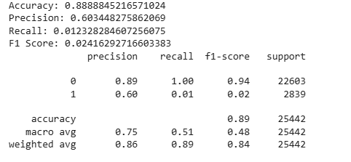
Figure 1 Confusion matrix of the Decision Tree classifier
The confusion matrix was analyzed to ensure that the model was majorly predicting the majority class which led to the occurrence of a huge number of true negatives but the occurrence of a high number of false negatives. This is typical in classification models that have been trained on a very uneven healthcare dataset, in which the minority class is underrepresented. Consequently this model gave importance to overall accuracy as opposed to sensitivity to clinically important cases. The findings show that accuracy is not a sufficient measure of comparing predictive models in the healthcare profession. Recall might be more important than accuracy in patient risk assessment applications, because the inability to automatically detect high-risk persons can result in the failure to promptly take medical action. Thus, though the accuracy is high, there is a low recall rate of the early readmission, which makes the model highly ineffective in its current form as a predictive measure.
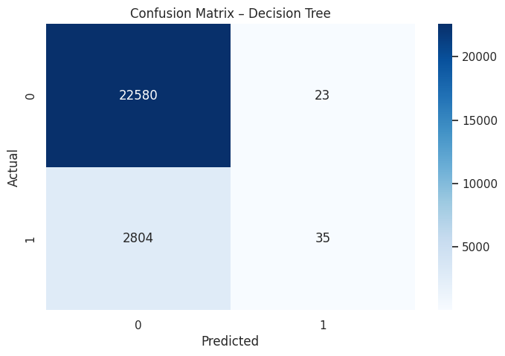
Figure 2 Confusion Matrix
Irrespective of its shortcomings, the Decision Tree model offers good interpretability. Analysis of the tree structure shows that such variables as the number of inpatient visits, length of hospital stay, and the number of medications affected the readmission risk considerably. These results are in line with the clinical knowledge, which makes the decision-making logic of the model credible. The Decision Tree classifier in a healthcare environment might be more of an explanatory or exploratory instrument as opposed to a predictive system by itself. Although it provides the clarity on the vital risk factors related to hospital readmission, additional optimisation needs to be undertaken to enhance the sensitivity to high-risk patients to be deployed in the real clinical workflow.
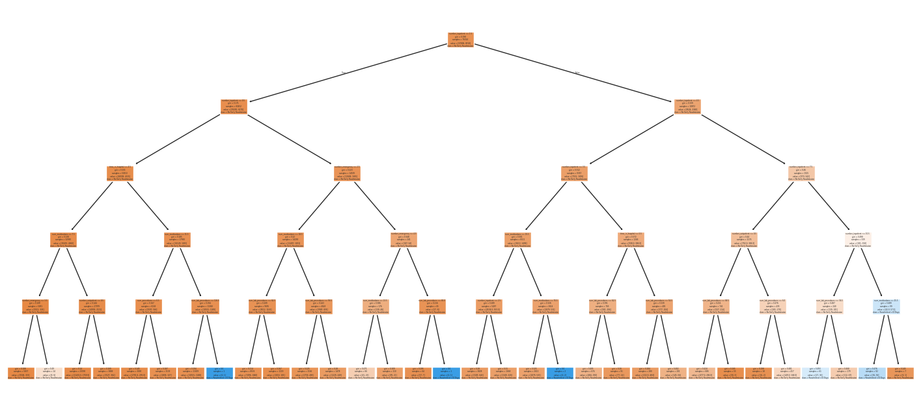
Figure 3 Trained Decision Tree structure
Unsupervised Learning Model: K-Means Clustering
K-Means clustering has been chosen over the dimensionality reduction techniques like Principal Component Analysis (PCA) as the goal of unsupervised analysis was to segment patients, and not to compress the features. K-Means directly clusters patients into interpretable categories using clinical and hospital utilisation traits which the healthcare planning and resource allocation is more practical to do. PCA can be practical in dimensional reduction but does not explicitly produce patient groups hence was not as agreeable to the goals of this research.
The unsupervised learning method that was used is K-Means to detect the hidden patterns and groupings of patients in the data that cannot be identified using labelled outcomes. Clustering in healthcare analytics is also especially helpful in patient segmentation, in that way hospitals can improve their comprehension of differences in patient complexity, resource utilisation and care needs. However, unlike supervised learning, K-Means does not use predetermined labels and rather clusters patients to each other on the basis of similarities between them on the selected clinical and hospital utilisation features. Before the clustering, the standardisation of feature scaling was done to make all variables equally important to the process of distance-based clustering.
This move was critical since K-Means is based on the Euclidean distance and it is very sensitive to variation of features. The identical numerical characteristics in the supervised model were kept to ensure consistency and to be able to draw meaningful contrasts between supervised and unsupervised insights. The Elbow Method was selected as the best method of estimating the optimal number of clusters, as it measures the relationship between the number of clusters and inertia within the cluster. The elbow plot reflected a slow decline in inertia without a sharply defined elbow point which is typical in complex healthcare data sets where the characteristics of patients have very large overlaps. According to this trend, three clusters were chosen as a conservative trade-off between the simplicity of the model and its interpretation.
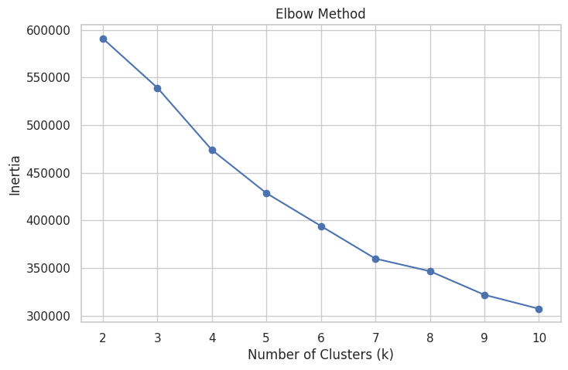
Figure 4 Elbow Method used to select the optimal number of clusters
The silhouette score was used to measure the quality of the cluster, and the score of every data point based on how well it fits in its cluster in comparison to other clusters. The score of silhouette was not that high, which implies the low separation of the clusters. This result is indicative of the natural heterogeneity of the patient health data since it is rarely clear where the boundaries of groups of patients lie. The clusters were not well differentiated, although they yielded high-level groupings that were meaningful when applied in clinical context.
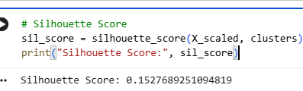
Cluster characteristics analysis demonstrated a certain patient profile. One cluster was characterised by increased length of stay, more medications and clinical procedures signifying increased medical complexity and use of resources. A second group was an indication of patients with moderate hospitalizations and more history of inpatient hospitalizations, indicating a medium-risk group with frequent healthcare requirements. The third group comprised of patients with less hospitalisation, fewer operations and general utilisation, which is a patient group at less risk.
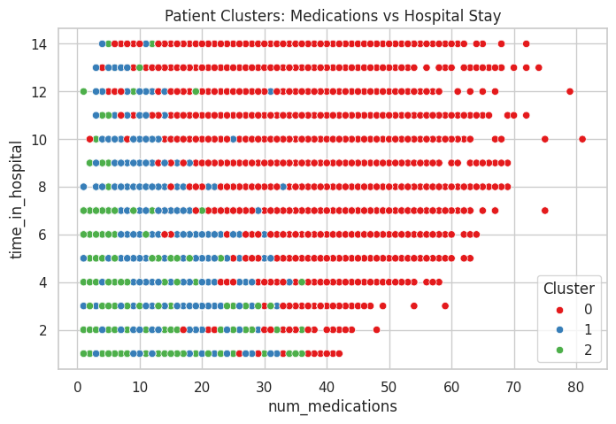
Figure 5 K-Means clustering results across key clinical features
The results of the clustering exhibit the usefulness of unsupervised learning in discovering patterns that cannot be directly observed using predictive modelling. The clusters did not show very clear segregations; however, they helped to obtain precious insights about patient complexity and patterns of healthcare utilisation. Such a segmentation in the real-life scenario of healthcare setting may facilitate hospital resource planning, patient stratification, and design of specific intervention strategies.
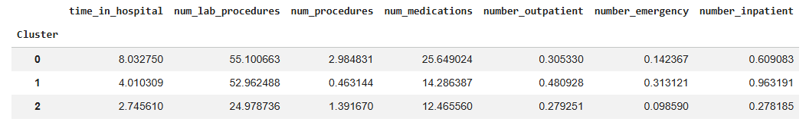
In general, K-Means clustering was used as a complement to the supervised Decision Tree model, as it will provide a more comprehensive and data-driven insight into patient groups. The supervised model concentrated on the early readmission prediction unlike the unsupervised model which emphasised on the structural patterns of the patient population, which validates the use of a combination of analytical methods whenever dealing with complex healthcare data.
Comparative Analysis of Supervised and Unsupervised Approaches

The supervised and unsupervised learning methods involved in the research were able to offer supplementary information about the healthcare information and each of them had a concern regarding analytical goals. The Decision Tree classifier was determined to predict a particular outcome, which is early hospital readmission, and learn relationships between patient characteristics and labelled outcomes. It proved to be effective in determining the major risk factors and provided a high degree of interpretability that is required in clinical decision-making. But it was highly affected by the imbalance of classes, as it inevitably predicted fewer minority cases of early readmission. In comparison, the K-Means clustering method did not strive to make any predictions but rather searched into the internal arrangement of the data. The latent patterns identified by clustering by groups of patients with similar characteristics of clinical and hospital utilisation were not explicitly indicated by the target variable. Even though the resulting clusters were poorly separating, they still gave significant segmentation of patients into low-, medium-, and high-complexity groups. This proves that unsupervised learning may reveal larger behaviour patterns than may be the case with supervised models. Combining the two approaches, it should be emphasized that predictive and exploratory methods are essential in healthcare analytics. Whereas the use of supervised learning facilitates the age-based decision, the use of unsupervised learning facilitates knowledge on the trends at the level of the population. By combining the lessons of the two strategies, more informed and sound healthcare plans can be developed.
Real-World Deployment and Human-in-the-Loop Integration
The machine learning models proposed would be implemented to hospitals as a decision-support system but not an autonomous tool in the real world. Decision Tree model may be incorporated into the processes of hospital discharges to identify patients at a greater risk of early readmission, and assist clinicians in the planning of care. Healthcare professionals would review these predictions and this would guarantee human-in-the-loop approach that upholds accountability and clinical judgement. On the same note, the K-Means clustering findings would help hospital administrators to determine high-complexity groups of patients who can receive special interventions and resources. These types of integrations increase efficiency without compromising on safety, transparency and ethical accountability.
Ethical, Legal, and Social Considerations

Ethical, legal, and social concerns are of significance in the application of machine learning in healthcare. The data used in the present study includes sensitive information about patients and, thus, the significance of data privacy, anonymisation, and adherence to regulations of healthcare data protection. Trained predictive models using imbalanced data can lead to bias, and thus to disadvantage, some vulnerable groups of patients as they might not be identified as at greater clinical risk. Also, overtrusting automated predictions partly may diminish the autonomy and responsibility of clinicians. As a solution to these risks, machine learning systems are to act as decision-support systems subject to human supervision, periodical performance audits, and transparent model explanation to ensure the responsible and ethical use in healthcare facilities.
Reflection, Challenges, and Limitations
A number of difficulties were experienced in the process of applying the supervised and unsupervised learning methods to this data. A major issue was a high level of disparity of classes in the target variable, with the cases of early readmission comprising a small percentage of the total dataset. This imbalance produced a Decision Tree model that was biased towards the majority class giving it high accuracy and poor recall on clinically significant cases. Such imbalance is an issue that needs to be addressed as it has the potential to be disastrous to healthcare applications when there is misclassification of high-risk patients. The complexity and heterogeneity of the data was also another issue. The patient records were diverse in terms of medical history, hospital utilisation and treatment pattern which also added to overlapping clusters in the K-Means analysis. This complexity and drawbacks of distance-based approaches to clustering high-dimensional healthcare data are described by the relatively low score of the silhouette. Also, K-Means utilises spherical clusters and equal variance, which are almost never met in the real clinical data. The models had also limitations that concerned feature representation and temporal dynamics. The data set does not record full patient histories or ongoing patient interactions between hospitals and instead captures single encounters of each hospital, which does not allow the modeling of long-term disease evolution or recurrent readmission patterns. In addition, the fact that the models are static fails to consider changing patient status and clinical practices with time. Nevertheless, the identified limitations can be used to derive important lessons that can guide the future. The methods, which may improve the inference and clustering results, include resampling strategies, cost sensitive learning, dimensionality reduction and ensemble models. The recognition of these limitations serves to illustrate the fact that critical assessment is necessary when using machine learning methods in complex fields.
Conclusion

This paper showed how supervised and unsupervised machine learning methods can be well applied to a healthcare dataset problem. The Decision Tree classifier offered understandable results of factors affecting early hospital readmission, which emphasised the significance of hospital stay length and healthcare utilisation factors. Despite the limitation of predictive performance due to the imbalance between classes, the model provided a strong explanatory power applicable in clinical decision support. The K-Means clustering analysis was used to supplement the supervised approach in revealing latent patient groups in terms of clinical complexity and resource utilization. Although the separation of clusters was poor, the results of the clustering made a contribution to the enlarging of the perspective of patient heterogeneity and the patterns of healthcare utilisation. Combined, these two methods give us a picture of the benefits of using a predictive and exploratory framework together to increase the use of data in decision-making in healthcare. In general, the results underline that machine learning models should be deployed with a great deal of consideration of data features, metrics of evaluation and ethical consequences. Properly applied, these models can help in making more appropriate clinical judgments, increase resource allocation and make healthcare systems more efficient.

References

Deswal, P. (2025). Machine learning in healthcare sector: Algorithms, applications, challenges and prospects [Review]. ResearchGate.

Diabetes 130-US hospitals for years 1999–2008 [Dataset]. UCI Machine Learning Repository.

Fathy, W. (2025). From statistical methods to deep learning approaches for ICU readmission prediction: A review. Journal of Biomedical Informatics.

Jiang, X., & Wang, B. (2024). Enhancing clinical decision making by predicting readmission risk in patients with heart failure using machine learning: Predictive model development study. JMIR Medical Informatics, 12, e58812.

Kolasa, K., et al. (2024). Systematic reviews of machine learning in healthcare: A meta-review of methods and applications. Expert Review of Medical Devices, 21(2), 123–145.

Liu, V. B., Sue, L. Y., & Wu, Y. (2024). Comparison of machine learning models for predicting 30-day readmission rates for patients with diabetes. Journal of Medical Artificial Intelligence, 7, Article 9179.

Msheik, B., & Yehya, A. (2024). Survey on knowledge representation models in healthcare. Information, 15(8), 435.

Raza, S. (2022). A machine learning model for predicting, diagnosing, and addressing diabetes hospital readmissions.

Sen, C. K. (2025). Getting started on artificial intelligence in health care and knowledge representation. Big Data Research in Healthcare, 3(1), 45–60.

